2. SweetHeaven (50 points)
You are given an unresponsive website (HTML + CSS + images). Your task is to make the site responsive.
The site layout should change according to the browser viewport / screen size.
You need to implement 1 layout: width <= 600p. The figures below represent this layout:
- width <= 600px (mobile)
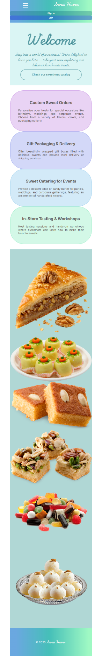

Output
The output should be valid HTML5 + CSS3 + images that implement the above responsive site.

Constraints
- You should write styles only in responsive.css file.
- The site should open correctly in the latest version of Chrome.

IMPORTANT: Do not change the structure of the provided exam resources. You may create files, but do not create new folders, rename existing ones, or move them to other directories.

HINTS: Here are some useful tips:
- The HTML file already includes a label for the hamburger menu.
- Check carefully provided screenshots. There should be a missing picture in the mobile version of the website.
- You can use Flexbox for the media query and the order property to arrange flex items.

